**Finger Strength Analysis**

An important piece of this project is the material in which the hand is printed. To help with material selection, the team did an analysis of a force on a finger. The finger was modeled as a static body using a square cross section. A force of 2 kilograms was chosen. This was chosen because if the whole hand was carrying a grocery bag or briefcase, the force would be distributed to the four fingers. This means the 2 kilogram force on one finger is equivalent to 8 kilograms held by the whole hand. The team decided this was a sufficient weight to symbolize what someone would carry.

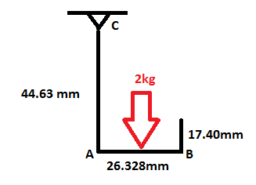

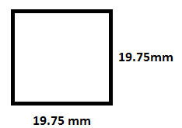

Static model Cross section

First, we calculated the moment about A to be used in the bending moment equation.

M=Force x Distance

M=(2 kg*9.81 m/s2) x (0.026328 m / 2)= 0.258 Nm

Next, we calculated the bending stress.

σb= My/I

I=b4/12 = (0.01975m)4 /12 = 1.27 x 10-8m4

σb= (0.258Nm)(0.01975m/2) / 1.27 x 10-8m4

σb= 200.3 kPa

Next, we calculated the maximum shear stress in segment AB.

Ʈ=3F/2bh

Ʈ =[3(2kg*9.81m/s2) / 2(0.01975m)2] = 75.4 kPa

Finally, we calculated the normal stress in segment AC.

σn= F/A

σn= (2 kg*9.81 m/s2) / (0.01975m)2 = 51.3 kPa

After the individual stresses were calculated, it was necessary to find the maximum total stress. It was determined that maximum stress would occur on the inside of segment AC, because the bending stress and normal stresses are additive.

σmax = σb + σn

σmax = 200.3 kPa + 51.3 kPa

σmax = 251.6 kPa